**Capstone Project Documentation**

**Student Name:** Rahul Pala

**Project title:** Adventure Galaxy

**INTRODUCTION**

**Purpose**

The purpose of Adventure Galaxy theme park website project is to enhance the overall visitor experience by addressing common pain points and offering unique features that set it apart from existing theme park websites.

1. **Enhance Visitor Experience**: By providing unique attractions and detailed ride information, visitors can plan their visits better and enjoy a more personalized experience.
2. **Reduce Wait Times**: Implementing real-time wait times and virtual queue management minimizes the time visitors spend standing in line, allowing them to explore more of the park.
3. **Improve Family Convenience**: Offering reservable family service rooms ensures that families have the necessary facilities to take care of their children comfortably.
4. **Increase Ride Transparency**: Real-time adrenaline ratings and clear height restrictions help visitors make informed decisions about which rides to go on, enhancing safety and enjoyment.
5. **Highlight Family-Friendly Options**: Providing information about family-friendly rides helps families with young children find suitable attractions quickly.

**Problems and opportunities that the project is investigating.**

**Problems:**

1. **Long Wait Times**: Visitors often spend a significant portion of their visit standing in lines, which can lead to frustration and a less enjoyable experience.
2. **Lack of Information**: Existing websites may not provide comprehensive information about ride adrenaline levels, height restrictions, and family-friendly options, leaving visitors uncertain about what to expect.
3. **Inconvenience for Families**: Parents with young children may struggle to find appropriate facilities, impacting their ability to enjoy the park.
4. **Inconsistent Ride Ratings**: Traditional ratings may not accurately reflect the real-time experience of a ride, leading to mismatched expectations.

**Opportunities:**

1. **Innovative Queue Management**: Allowing riders to make ride reservation is a unique feature that differentiates Adventure Galaxy, offering a competitive advantage by significantly enhancing the visitor experience.
2. **Comprehensive Ride Information**: Detailed, real-time data about rides, including wait times, adrenaline ratings, and height restrictions, provides visitors with the confidence to make informed decisions.
3. **Family-Focused Services**: By catering to the needs of families, Adventure galaxy can attract a wider audience and improve overall visitor satisfaction.
4. **Leverage Technology**: Utilizing advanced technology to provide real-time updates and notifications can streamline park operations and improve customer engagement.
5. **Building Trust and Transparency**: Real-time ratings and clear information build trust with visitors, potentially leading to increased customer loyalty and positive word-of-mouth.

**Addressing this problem is valuable for several key reasons:**

**Enhancing Visitor Experience and Satisfaction:**

1. **Reduced Wait Times**: Long wait times are a significant pain point for theme park visitors. By offering real-time wait times and virtual queue management, and ability to reverse family service rooms, visitors can enjoy more attractions with less time spent standing in lines, leading to a more enjoyable and satisfying experience.
2. **Improved Planning and Convenience**: Providing detailed ride information, including adrenaline ratings, height restrictions, and family-friendly indicators, helps visitors plan their day more effectively, ensuring they make the most of their time at the park.

**Attracting and Retaining Visitors:**

1. **Unique Selling Points**: Features like virtual queue management and reservable family service rooms set Adventure Galaxy theme park apart from competitors, making it more attractive to potential visitors.
2. **Family-Friendly Environment**: By catering to families with young children through reservable family service rooms and clear information about family-friendly rides, we attract a broader audience and enhance the park's reputation as a family-friendly destination.

**Leveraging Technology for Efficiency:**

1. **Operational Efficiency**: Real-time updates and virtual queue management streamline park operations, helping to manage crowds more effectively and reducing the strain on staff.
2. **Informed Decisions**: Real-time adrenaline ratings provide up-to-date feedback on rides, helping visitors make informed decisions based on the most current experiences of other visitors.

**Building Trust and Loyalty:**

1. **Transparency**: Clear information on ride wait times, adrenaline ratings, height restrictions, family service reservation option and family-friendly options builds trust with visitors, who feel confident in the park's transparency and commitment to their enjoyment and safety.
2. **Positive Word-of-Mouth**: Satisfied visitors are more likely to share their positive experiences with others, leading to increased word-of-mouth referrals and repeat visits.

**Addressing Common Pain Points:**

1. **Reduced Stress for Parents**: Providing reservable family service rooms addresses the needs of parents, reducing their stress and making the park experience more enjoyable for families.
2. **Enhanced Safety**: Clear height restrictions and ride information help ensure that visitors choose rides appropriate for their age and size, reducing the risk of accidents and enhancing overall safety.

**Competitive Advantage:**

1. **Market Differentiation**: By offering unique features not available on other theme park websites, Adventure Galaxy gains a competitive advantage, attracting more visitors who value these enhanced services.
2. **Innovation and Modernization**: Embracing advanced technology and innovative solutions positions Adventure Galaxy as a modern and forward-thinking destination, appealing to tech-savvy visitors.

**What is the current state?**

1. **Long Wait Times**: Visitors often experience long wait times for rides, leading to frustration and a less enjoyable experience.
2. **Lack of Real-Time Information**: Many theme park websites do not provide real-time wait times for rides, leaving visitors uncertain about how long they will have to wait.
3. **No Virtual Queue Management**: Visitors must physically stand in line for rides, which can be tiring and time-consuming.
4. **Limited Family Facilities**: Theme parks may have family service rooms, but the ability to reserve them online is typically unavailable, making it inconvenient for parents.
5. **Inconsistent Ride Ratings**: Ride ratings are often static and do not reflect real-time visitor experiences, leading to potential mismatches in expectations.
6. **Unclear Ride Restrictions**: Height restrictions and other safety information are not always prominently displayed, leading to confusion and potential safety issues.
7. **Insufficient Family-Friendly Information**: Information about which rides are suitable for families is not always readily available, making it difficult for families to plan their day.

**What is the desired state**?

1. **Reduced Wait Times**: Visitors experience shorter wait times due to the availability of real-time wait times and virtual queue management.
2. **Access to Real-Time Information**: The website provides real-time updates on wait times for each ride, allowing visitors to plan their activities more efficiently.
3. **Virtual Queue Management**: Visitors can reserve a spot in line via the website and receive notifications when it’s their turn to ride, eliminating the need to physically stand in line.
4. **Convenient Family Facilities**: Parents can reserve family service rooms online, ensuring they have a convenient and private space to take care of their children’s needs.
5. **Real-Time Adrenaline Ratings**: Visitors can rate rides in real-time, providing current and relevant feedback to help others make informed decisions.
6. **Clear Ride Restrictions**: Height restrictions and other safety information are clearly displayed for each ride, ensuring visitors can quickly determine if a ride is suitable for them or their children.
7. **Comprehensive Family-Friendly Information**: The website clearly indicates which rides are family-friendly, helping families to plan their visit and ensure they choose appropriate attractions for their group.

**Problem addressed by other projects and outcome.**

The problem of long wait times, lack of real-time information, no option of attractions and family services reservations in theme parks has been partially addressed by other projects, though not comprehensively. Some theme parks have implemented real-time wait time tracking and mobile apps to provide updates and ride information. For example, Disney's FastPass and Universal's Express Pass systems allow guests to reserve access to attractions, reducing wait times. However, while these efforts have improved visitor experiences by reducing wait times and providing better information, they often fall short in offering a fully integrated solution that includes real-time ratings, comprehensive ride details, and online family service reservations. As a result, the outcomes have been positive but limited, indicating a need for a more holistic approach to address these issues comprehensively.

**Industry/Domain**

The industry in focus is the theme park and amusement park industry, which includes various entertainment attractions such as rides, shows, and themed areas designed to provide recreational experiences to visitors.

**Current State of the Industry:**

1. **Recovery and Growth Post-Pandemic**: The theme park industry is recovering from the impact of the COVID-19 pandemic, with an increasing number of visitors returning to parks and a focus on enhancing visitor experiences.
2. **Technological Integration**: Many parks are adopting technology to improve visitor experiences, including mobile apps for navigation, wait times, and virtual ticketing systems.
3. **Competition from Startups**: Startups are challenging traditional parks by introducing innovative solutions, such as immersive virtual experiences and advanced queue management systems.
4. **Sustainability Concerns**: There is a growing emphasis on sustainability and eco-friendly practices within the industry.
5. **Health and Safety**: Enhanced health and safety measures are being prioritized to ensure visitor safety considering recent global health concerns.

**Overall Industry Value-Chain:**

1. **Design and Development**: Creation of rides, attractions, and themed areas, often involving collaboration with designers, engineers, and artists.
2. **Construction**: Building the physical infrastructure of the theme park, including rides, buildings, and amenities.
3. **Operations**: Day-to-day management of the park, including staffing, maintenance, and safety inspections.
4. **Marketing and Sales**: Promoting the park to potential visitors through advertising, partnerships, and ticket sales.
5. **Guest Services**: Providing a range of services to enhance visitor experiences, such as customer support, dining, and retail.
6. **Technology Integration**: Implementing technological solutions to improve operations and visitor experiences, such as mobile apps, virtual queues, and real-time information systems.

**Key Concepts in the Industry:**

1. **Visitor Experience**: The overall satisfaction of visitors, influenced by factors like wait times, attractions, amenities, and customer service.
2. **Queue Management**: Strategies to manage and reduce wait times for attractions, improving visitor flow and satisfaction.
3. **Real-Time Information**: Providing up-to-date information on wait times, ride statuses, and park events.
4. **Family-Friendly Services**: Amenities and services tailored to families, such as childcare facilities and family-friendly attractions.
5. **Safety and Regulations**: Ensuring all attractions meet safety standards and regulations to protect visitors.
6. **Technological Innovation**: Using technology to enhance the visitor experience and streamline operations.

**Relevance to Other Industries:**

The project has relevance to several other industries, including:

1. **Hospitality and Tourism**: The focus on improving visitor experiences and integrating technology can be applied to hotels, resorts, and tourist attractions.
2. **Event Management**: Queue management and real-time information systems can benefit large events and festivals.
3. **Retail**: Real-time ratings and queue management can enhance customer experiences in retail settings.
4. **Healthcare**: Virtual queue management and real-time information can improve patient flow and satisfaction in healthcare facilities.
5. **Entertainment**: Similar principles can be applied to cinemas, theatres, and other entertainment venues to enhance customer experiences.

**Stakeholders**:

1. **Theme Park Visitors**:
   * **Access**: Full access to the website's features, including ride and shows information, real-time wait times, ride reservations, family service room reservations, adrenaline ratings, height restrictions, and family-friendly ride information.
   * **Why They Care**: Visitors want a convenient and enjoyable experience, minimizing wait times, accessing reliable information, and ensuring the park is suitable for all family members.
   * **Expectations**: Accurate real-time information, ease of use, reduced wait times, and enhanced overall park experience.
2. **Theme Park Management and Staff**:
   * **Access**: Administrative access to manage and update real-time information, monitor virtual queues, handle family service room reservations, and review ride ratings and visitor feedback.
   * **Why They Care**: Management aims to improve operational efficiency, enhance visitor satisfaction, and gather data to make informed decisions.
   * **Expectations**: Reliable system performance, ease of managing and updating information, insightful analytics, and positive visitor feedback.
3. **Ride Operators and Maintenance Staff**:
   * **Access**: Operational access to update ride statuses, manage wait times, and monitor ride-specific feedback.
   * **Why They Care**: Ride operators and maintenance staff need accurate information to ensure rides are operating smoothly and safely, addressing any issues promptly.
   * **Expectations**: Accurate and timely updates, ease of reporting and managing ride statuses, and reduced operational disruptions.
4. **IT and Support Teams**:
   * **Access**: Full administrative access to maintain, troubleshoot, and update the website and its features.
   * **Why They Care**: Ensuring the website runs smoothly, securely, and efficiently without downtime.
   * **Expectations**: Robust and secure software, ease of maintenance, and prompt resolution of any technical issues.
5. **Marketing and Sales Teams**:
   * **Access**: Access to visitor data, ride ratings, and usage analytics to tailor marketing strategies and promotional activities.
   * **Why They Care**: To attract more visitors, enhance brand reputation, and increase ticket sales.
   * **Expectations**: Insightful analytics, positive visitor reviews and feedback, and increased visitor engagement and satisfaction.

**PRODUCT DESCRIPTION**

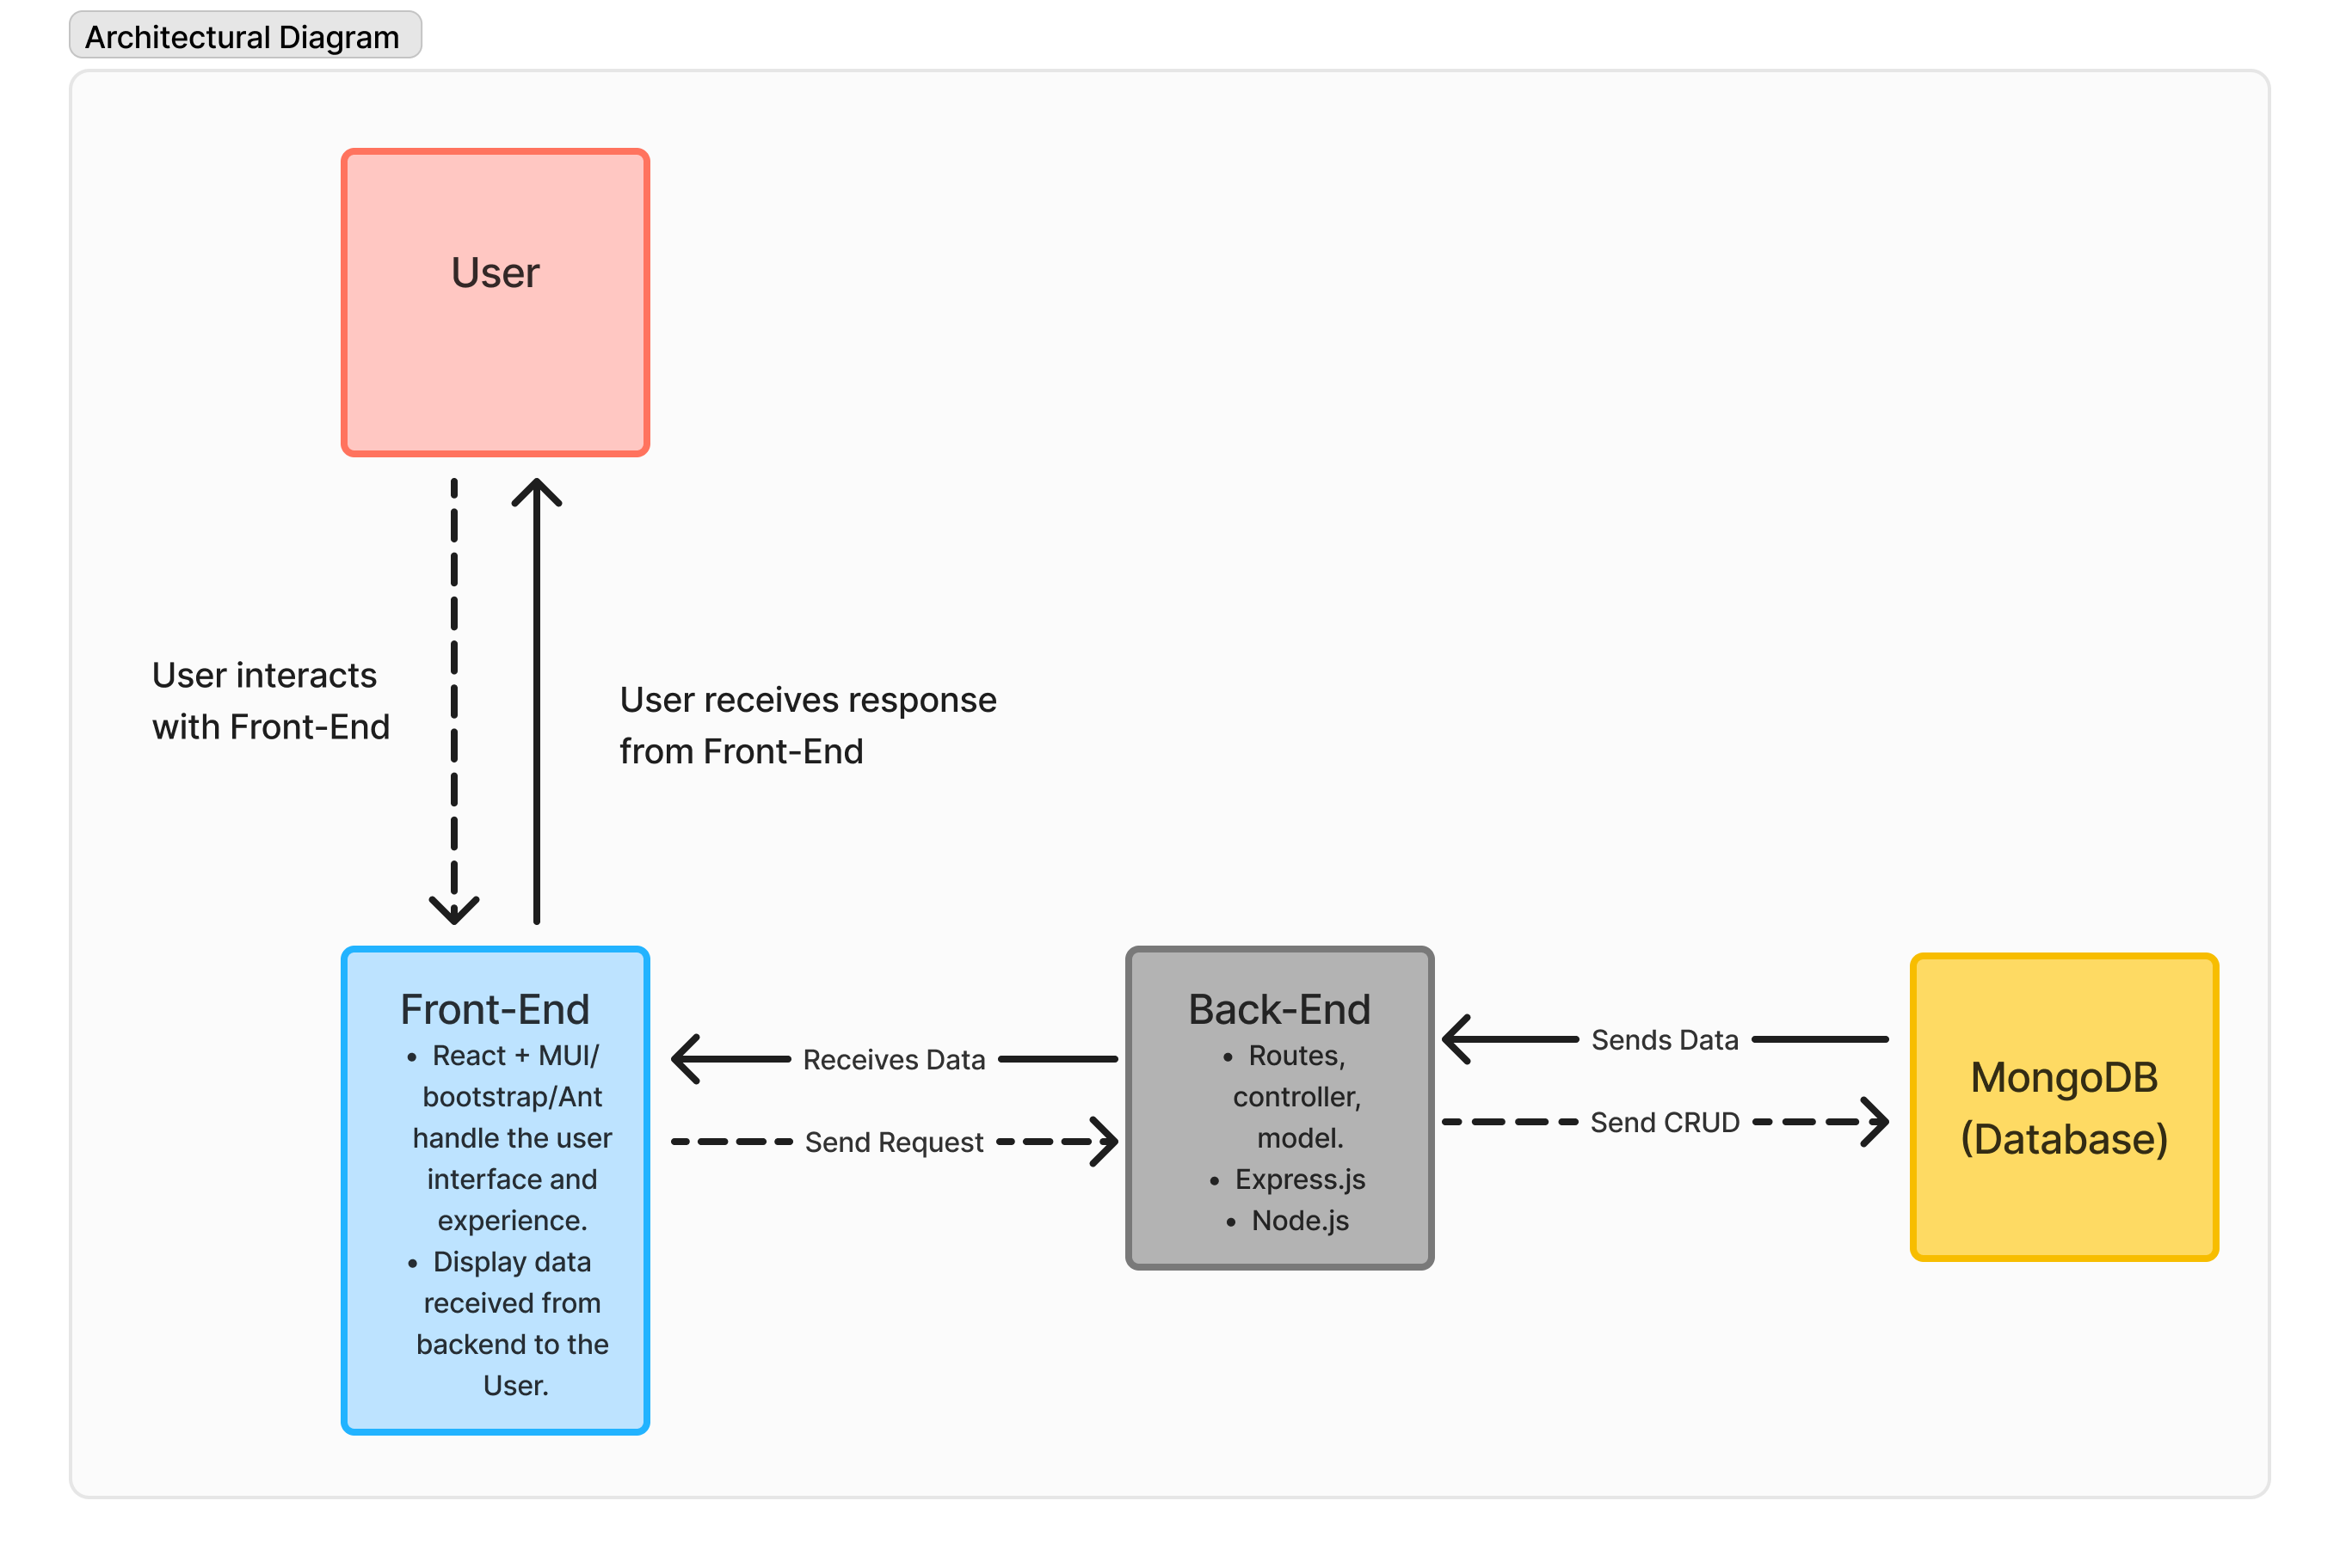

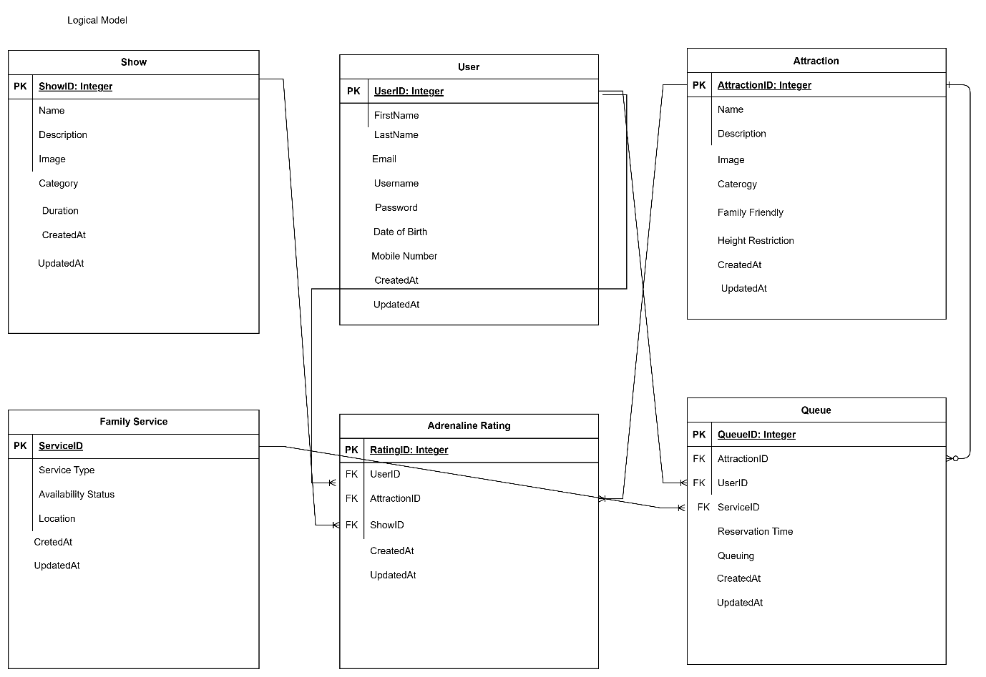

**Physical Model**

**Wireframe Design**

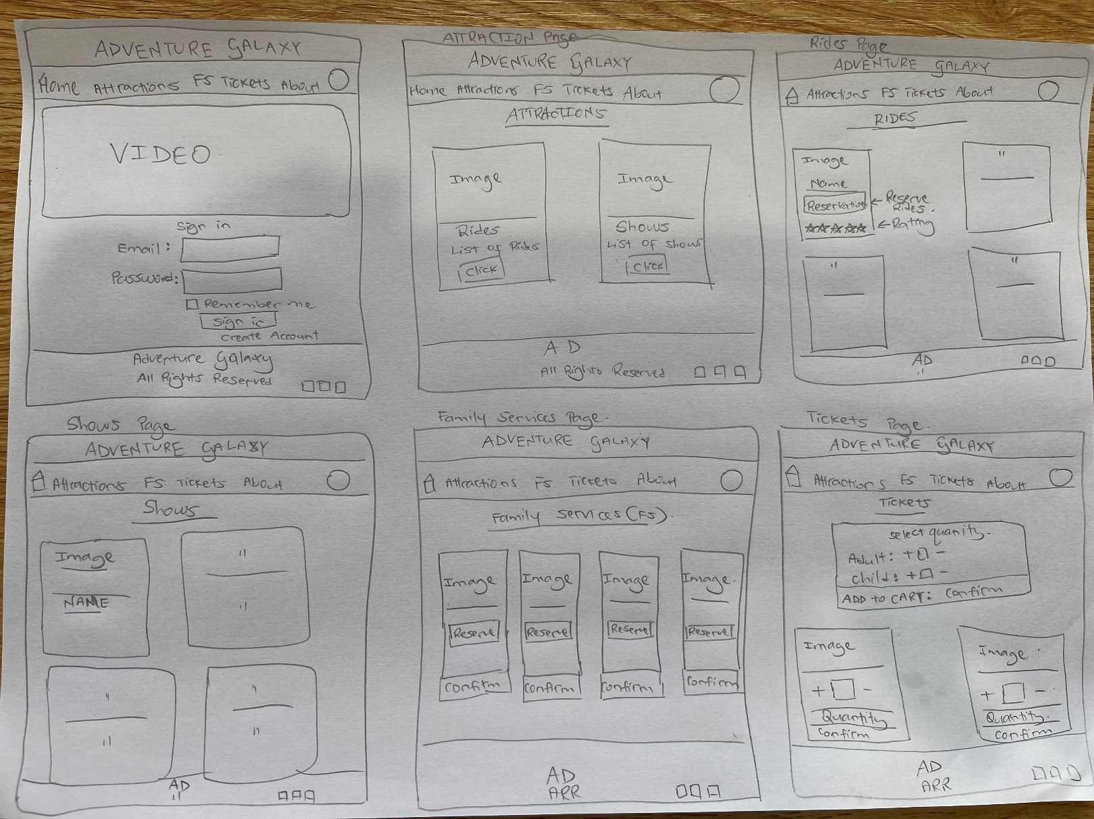**Sketch**

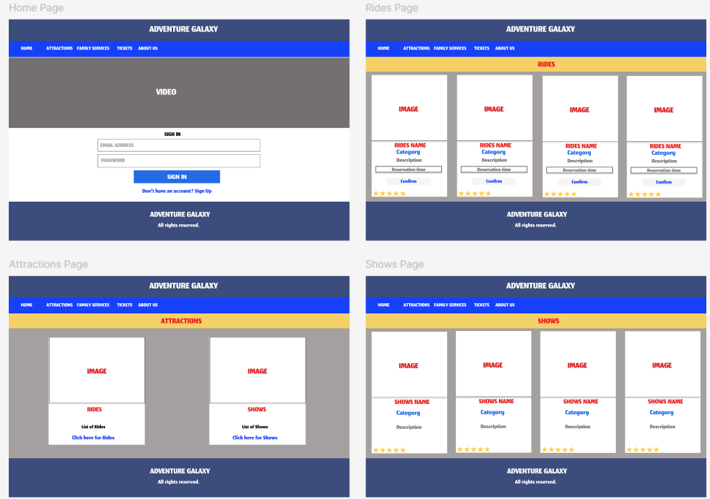

**User Stories**

|  |  |  |  |  |
| --- | --- | --- | --- | --- |
|  | **User Story Title** | **User Story Description** | **Priority** | **Additional Notes** |
| 1 | Create an Account | As a visitor, I want to create an account so that I can save my preferences and manage my reservations. | Medium | Include options for social media login. |
| 2 | Login to My Account | As a visitor, I want to log in to my account so that I can access my saved preferences and reservations. | Medium | Implement a secure login system. |
| 3 | View Unique Attractions | As a visitor, I want to view the list of unique attractions so that I can decide which ones I want to visit. | High | Include detailed descriptions, images, and videos of each attraction. |
| 4 | Check Real-Time Wait Times | As a visitor, I want to see real-time wait times for each attraction so that I can plan my day efficiently. | High | Display updated wait times prominently on the attraction pages. |
| 5 | Make a Reservation for an Attraction | As a visitor, I want to make reservation for an attraction via the website so that I don't have to physically wait in line. | High | Implement a system to manage reservations and send notifications when it's the user's turn. |
| 6 | Receive Notifications for reminder regarding reservation | As a visitor, I want to receive notifications when it's my turn to ride an attraction so that I can arrive at the ride on time. | High | Notifications should be sent via SMS, email, or push notifications. |
| 7 | View Real-Time Adrenaline Ratings | As a visitor, I want to view real-time adrenaline ratings for rides so that I can choose the most exciting attractions. | High | Display adrenaline ratings alongside ride descriptions. |
| 8 | Rate Ride Experience  (Reviews) | As a visitor, I want to rate how good the ride was so that I can share my experience with others. | Medium | Implement a rating system with an adrenaline meter to capture the excitement level of the ride. |
| 9 | Check Height Restrictions | As a visitor, I want to check the height restrictions for each ride so that I can ensure I meet the requirements. | High | Clearly display height restrictions on each ride's page. |
| 10 | View My Reservations | As a visitor, I want to view my reservations so that I can manage my schedule for the day. | High | Include options to edit or cancel reservations. |
| 11 | Purchase Tickets | As a visitor, I want to purchase tickets online so that I can enter the park without having to wait in line at the ticket booth. | High | Include various payment options and send confirmation emails. |
| 12 | Search for Attractions | As a visitor, I want to search for attractions by name or category so that I can find specific rides easily. | High | Implement a robust search functionality. |
| 13 | Contact Customer Support | As a visitor, I want to contact customer support if I encounter any issues so that I can get assistance. | Medium | Provide multiple contact options such as chat, email, and phone. |
| 14 | View and reserve Family Service facilities | As a visitor, I want to view and reserve family service facilities for feeding, changing etc. | High | Provide clear instructions to view and reserve family facilities. |

Out of Scope

**Optimization of Mobile App:**

* Developing or optimizing a mobile application is outside the scope of the website project.

**E-commerce Integration:**

* Online store for merchandise and food orders.

**Social Media Integration:**

* Sharing ratings and experiences directly to social media.
* Social media feed or live updates from the park.

**Augmented Reality (AR) Features:**

* Virtual tours of the park.
* AR-enhanced maps and navigation within the park.

**Comprehensive User Accounts:**

* Detailed user profiles beyond basic reservation and rating information.
* User-generated content such as photos or reviews.

**Personalized Experience Recommendations:**

* AI-based recommendations for rides and shows based on user preferences.
* Personalized itineraries for visitors.

**Multilingual Support:**

* Full multilingual website with content available in multiple languages.

**Third-party Integrations:**

* Integrations with external travel or accommodation booking services.
* Partnerships with other local attractions or businesses.

**Detailed Accessibility Information:**

* Extensive details on accessibility features for each ride and show.
* Specific accommodations for visitors with disabilities.

**Seasonal and Special Event Pages:**

* Dedicated pages for seasonal events and promotions.
* Special event booking and management.

**Non-functional Requirements**

**Security Requirements:**

1. **Authentication and Authorization**:
   * Secure login and registration process.
   * Multi-factor authentication (MFA) for added security.
   * Role-based access control (RBAC) to manage permissions.
2. **Data Protection**:
   * Personal details, including payment information, must be stored securely.
   * Use encryption for data in transit and at rest.
   * Implement secure password storage practices (e.g., hashing and salting).
3. **Inactivity Timeout**:
   * Automatic session timeout after a specified period of inactivity (15-30 minutes).
4. **Data Privacy**:
   * Clear privacy policy outlining data usage and user rights.

**Performance Requirements:**

1. **Transaction Throughput**:
   * The website should handle a high number of transactions during peak times (e.g., 500-1000 transactions per second).
2. **Response Time**:
   * Page load times should be under 2 seconds.
   * Real-time data (e.g., wait times, notifications) should update within 1 second.

**Usability Requirements**

1. **Ease of Use**:
   * Should be very easy and user-friendly interface with clear navigation.
   * Mobile-friendly design for use on smartphones and tablets.
   * Needs to be easy enough for new staffs if they were newly recruited.

**Reliability & availability Requirements**

* + The website should have an uptime of at least 99.9%.
  + Implement redundancy and failover mechanisms to ensure high availability.

**Maintainability Requirements:**

1. **Modularity**:
   * Design the system in a modular fashion to ease updates and maintenance.
   * Back-End – Uses MVC structure for ease of use.
   * Front-End – Used proper components, custom hooks for data reuse.
2. **Scalability**:
   * Design the system to easily scale horizontally or vertically to accommodate increased load.

|  |  |  |
| --- | --- | --- |
| **DATE** | **PLANNING** | **OUTCOME** |
| 05/07/2024 | Start Project planning  -Decide which project to do  -Create GitHub Repository and clone | Done |
| 06/07/2024 | Start documentation  -complete Purpose section | Done |
| 07/07/2024 | Documentation  -Start and complete Industry/domain section  -Start and complete Stakeholders section  -Start and complete Open questions/Out of Scope section  -Start and complete Non-functional Requirements | -Need to research more on out-of-scope section.  -Others Done |
| 08/07/2024 | -Start & complete ‘Sketch ‘  -Start Logical model | -Had to correct/update logical model twice as it had errors. |
| 09/07/2024 | -Complete Logical model  -Start & complete Physical model  -Start Lo-Fi design | Done |
| 10/07/2024 | -Start and complete Hi-Fi design on Figma.  -Do User stories.  -Do User Flow diagrams  -Tidy up and complete documentation section | Done |
| 11/07/2024 | Start backend task  -Create backend template  -Create MVC model  -Complete User, Attractions, and shows model,  View and controller.  -Perform CRUD operations | -followed examples from Miniproject 2  -Done |
| 12/07/2024 | Backend  -complete Services, adrenaline and Queue model, view and controller.  -Perform CRUD operations | Done |
| 13/07/2024 | Backend  -Update foreign keys.  -Perform Crud operations | Done |
| 14/07/2024 | Start Frontend  -Create components, Hooks, Context, Pages, Routes etc folders.  -Set AppRoutes – routes should work  -Start working on home page (Title, Navbar and footer) | -Navigation working.  -Title set  -Took time getting NavBar from MUI. |
| 15/07/2024 | -Set navigation from NavBar.  -Create sign-In form for homepage. | -Got help to set NavBar navigation.  -Done |
| 16/07/2024 | Start working on attractions page  -create cards.  -set navigation. | Done |
| 17/07/2024 | Start working on Rides and shows page  -Create cards from MUI  -select and add date and time pickers from MUI.  -select and add Ratings from MUI. | -Took day-off and help  -Done |
| 18/07/2024 | -Set video on home page.  Start working on Family Service and Tickets Page.  -Create Cards.  -Add counter buttons to tickets page.  -Work in Create account page – sign up template from MUI. | -Took day -off and help.  -Done |
| 19/07/2024 | -Fill in Abouts page with text.  -Use UseContext for sign in.  -Start with Logic. | Done |
| 20/07/2024 | NIL – Work and Family Function. |  |
| 21/07/2024 | Work on logic | Done |
| 22/07/2024 | -work on CRUD operations on Rides.  -Work on CRUD operations on shows | Done |
| 23/07/2024 | -work on CRUD operations on Family Service | Done |
| 24/07/2024 | -Login Logic | Done |
| 25/07/2024 | -Login Logic  -Reservation logic  -Record Presentation | Done |
| 26/07/2024 | Submit | Done |
| 27/07/2024 | PRESENTATION DAY! |  |

**Testing Strategy**

* Followed Figma design.
* Postman and Thunderclient was used to test CRUD operation for backend and database.
* Every component was tested, and errors were resolved.
* To Catch errors and odd results, concole.log method was used.

**Implementation**

**Current State**

Currently, the software is running locally on my development machine. It includes most the basic functionalities and the primary features The local setup uses a local server for development and testing purposes.

**Considerations for Deployment**

1. **Scalability**: Ensuring the website can handle a large number of visitors simultaneously, especially during peak times.
2. **Security**: Implementing robust security measures to protect user data and prevent unauthorized access.
3. **Performance Optimization**: Optimizing the website's performance to ensure fast load times and a smooth user experience.
4. **Backup and Recovery**: Setting up regular backups and a recovery plan to prevent data loss.
5. **Compliance**: Ensuring the website complies with legal and regulatory requirements, especially regarding data protection and privacy.
6. **Monitoring and Maintenance**: Setting up monitoring tools to track the website's performance and implementing a maintenance plan for regular updates and bug fixes.

**Future Plans**

After adding all the planned features and refining the website, the next steps will be:

1. **Hosting on the Cloud**: We will move the website from the local environment to a cloud hosting service. Cloud providers such as AWS, Azure, or Google Cloud offer scalable and reliable hosting solutions.
2. **Domain Registration**: Registering a domain name for the website to make it accessible to the public.
3. **Database Integration**: Using a cloud-based database service for storing and managing data efficiently.
4. **Load Balancing**: Implementing load balancing to distribute traffic evenly across multiple servers, ensuring reliability and availability.
5. **Content Delivery Network (CDN)**: Using a CDN to deliver content quickly to users based on their geographical location, improving load times and performance.
6. **User Authentication and Authorization**: Implementing a secure authentication system to manage user access and protect sensitive information.
7. **Analytics and Reporting**: Integrating analytics tools to track user interactions, monitor performance, and gather insights for continuous improvement.

**End-to-end solution**

The application is fully functional and has met the requirements.

**References**

* The code used in the project can be found in GitHub

[Rahul-Pala/CapstoneProject (github.com)](https://github.com/Rahul-Pala/CapstoneProject)

* A readme file can also be found in the same repository.
* React
* MUI
* React Bootstrap
* Nodemon
* React Icons
* Axios
* Express JS
* Thunderclient
* Postman
* MongoDB
* Mongoose